## **Course 4 - Network Security & Database Vulnerabilities**

**Practice Lab: Security Vulnerability Scan and Fix**

**Task 1**

1. Provide a screenshot showing that you have forked the godot repository to your GitHub account. (2 pts)

**Task 2**

1. Provide a screenshot from your Snyk Projects page showing that you have imported and scanned your godot fork. (2 pts)

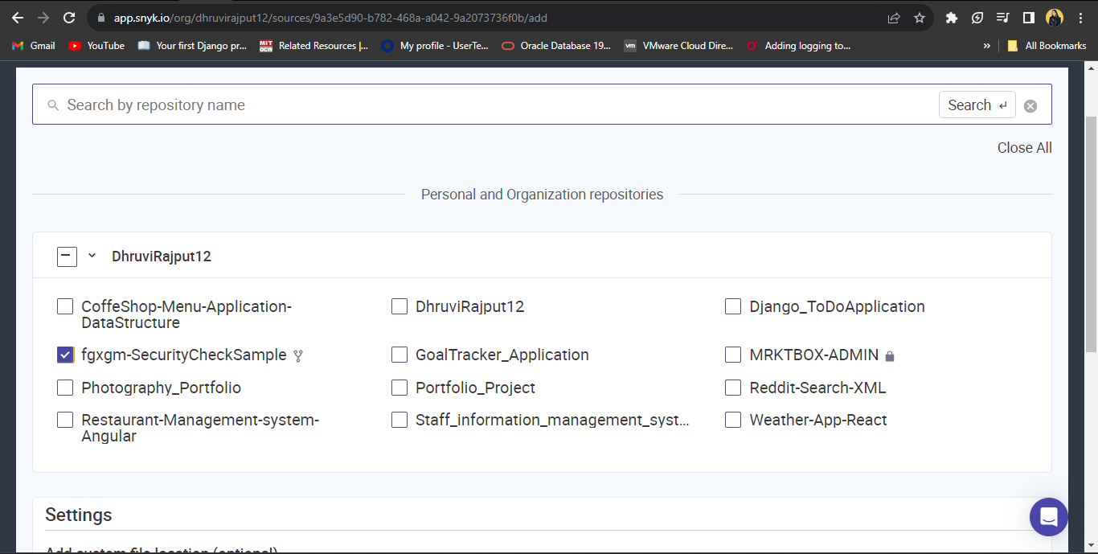

1. Provide a screenshot showing the Snyk Overview page that displays the results from scanning your godot fork. (2 pts)

